**JUnit**

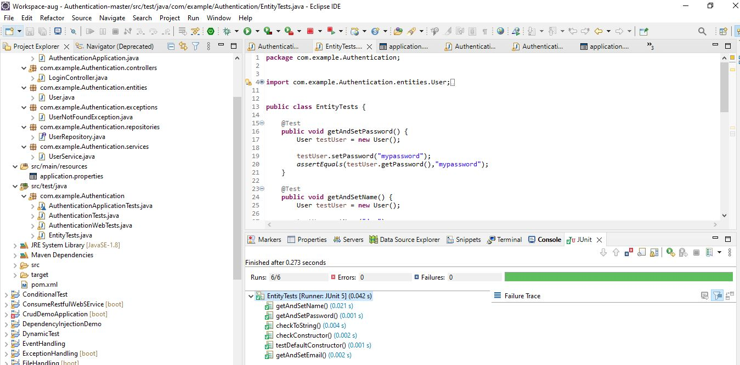

**Test case is executed.**